# 进展报告

## Goal

为了提高FDM打印模型的强度，我们优化填充方式，实现平面内连续打印并保证拐点少，同时将平面内的连续费马螺线填充映射到曲面当中。将生成的轮廓路径转化为对应的G-code，包括生成预处理代码和后处理代码。主要目标为：

1. 生成连续的费马螺线填充;
2. 生成对应的G-code，包含预处理代码、打印路径代码和后处理代码;打印填充平面
3. 自由曲面当中的连续填充。

## Proposed Strategies

1. 为了生成连续的填充方式，我们考虑生成连续费马螺线轮廓来填充。我们同样依据模型外轮廓利用轮廓平行算法得到相应的轮廓平行填充，但轮廓平行填充轮廓之间相互独立、不相连接，不利于模型的强度，故对其进行路径重新规划：不同于who的处理方式我们根据奇偶层分别生成单向螺线，随后将其连接，并且保证方向为单向进出，即实现连续费马螺线填充。
2. G-code

根据材料和硬件设备生成相应的预处理代码和后处理代码，包括挤出丝材的宽度、热床和喷头温度等。同时依照所得连续费马螺线的轮廓路径点生成对应的打印路径。代码中设置相关的偏移量和挤出量参数影响打印过程中轮廓的紧密程度以及费马螺线是否会相互干涉。

1. 曲面映射

简单圆柱面的映射自由曲面映射为平面，填充平面，随后映射回自由曲面形成曲面连续填充。同时考虑自由曲面的映射，包括近似展开方法和NURBS展开方法。

## Achieved

1. 螺线轮廓和连续费马螺线轮廓

输入STL模型，我们依据模型轮廓利用轮廓平行算法生成了轮廓填充，随后通过路径规划得到了单螺线填充和连续费马螺线填充，保证了打印丝材的连续性，同时减少了填充轮廓的拐点数目和道具空行程，相较于传统zigzag填充减少了材料累积影响的模型强度问题。

在路径重规划中我们设置了打印的起始，寻找到每层的终止点与下一层相连，连接最终的相邻两层的终止点得到连续费马螺线轮廓。

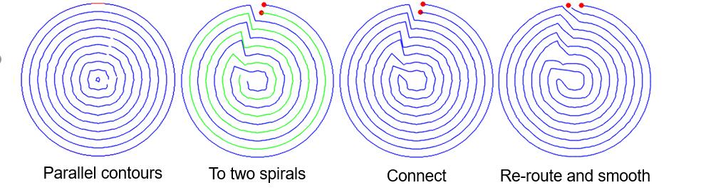

2、输出G-code以及参数的调整

G-code：利用已有G-code和硬件设备，设置相应参数得到G-code前处理和后处理代码。利用前文所述的连续费马螺线轮廓输出相应X，Y坐标得到G-code。输出的G-code用于打印制造。

参数调整：生成费马螺线与生成轮廓平行时的偏移量offset有关，offset值较大多层轮廓之间的距离大，稀疏填充但是强度太差；offset值较小会导致丝材之间粘连，同时可能会对费马螺线轮廓之间连接产生干涉。故我们考虑丝材本身的直径以及其在热床上的宽度来选择合适的偏移量。

在G代码生成中E为两点之间丝材的挤出量，在本文中选用绝对值，E值的选定与两点之间的距离成一定的比例。如两点A（x1,y1）、B(x2,y2)，其间的距离与两点设置的绝对挤出量E1，E2的关系为如下公式。E值太小则会导致出丝量不够，挤出丝材过细从而影响打印强度；E值太大则会破坏层之间的轮廓，甚至。根据测试中的打印表现选择相应的E值。

打印过程和结果如下列图。调整了offset值之后费马螺线之间的连接未受到干涉，同时因为代码中的平滑处理，轮廓之间的连接过度较为平滑，但局部仍然存在填充不足、丝材稀疏的现象。



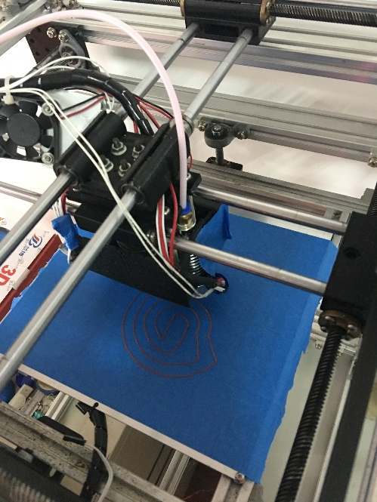

打印过程

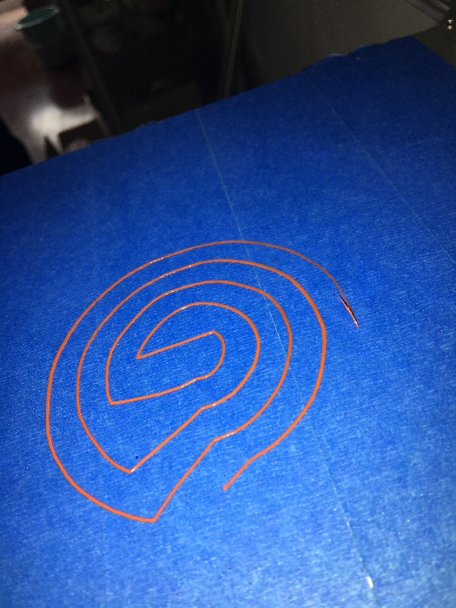

单层稀疏填充

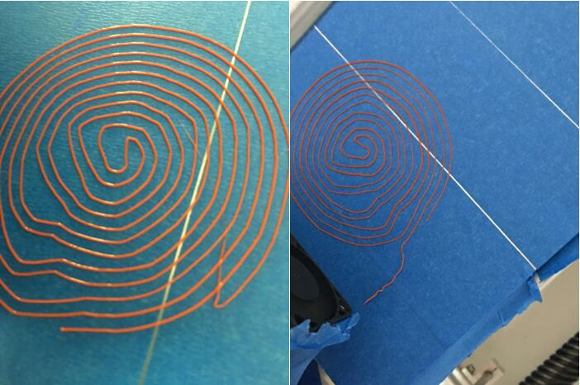

单层密集填充

3、曲面映射

根据曲面理论，三维曲面可分为平面、直纹面和空间曲面。根据曲面的可展性又可分为可展曲面和不可展曲面。可展曲面是高斯曲率处处为零的曲面，常见的单参数平面族的包络面是可展曲面,但是如果用双参数来设计曲面，则很难满足可展性。空间曲面映射为平面的精度可以通过以下几个指标衡量：相对面积误差、相对角度误差、相对长度误差。因此映射可以大致分为1、等角映射2、等面积映射3、任意映射4、特殊点映射5、等距映射。

我们需要将空间曲面映射为平面，随后利用连续费马螺线填充二维平面，根据曲面和平面之间的相互关系转化为曲面中的连续费马螺线填充。

空间曲面可以映射到可展曲面上，随后展开相应的可展曲面。几种近似展开方法：单圆锥映射法、多圆锥逼近法、圆柱映射法。圆柱映射法：假定以圆柱面作为映射，把空间曲面映射到圆柱面，然后依照上述过程中展开圆柱面形成平面。

考虑简单的圆柱面的曲面填充形式，对于圆柱面其展开为长方形，我们利用长方形外轮廓生成连续费马螺线。

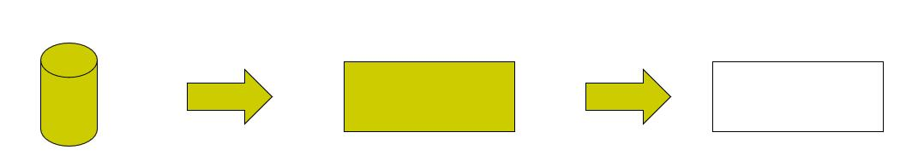

自由曲面的填充：曲面映射时其上点的相互位置总是要发生变动，曲面上的几何特性曲线长度、方向和曲面面积受到破坏。

NURBS曲面的平面映射：NURBS曲面对标准曲线、曲面和自由线、曲面提供了统一的数学参数表示;而且可以通过权因子和控制点来灵活地改变曲面的形状;个别控制顶点和权因子的调整只影响曲面的局部。利用这些特点, 可以用它构造各种复杂的曲面造型和表面特殊的效果。

NURBS曲面为不可展曲面，不可展曲面的展开有以下几种方法：几何展开法、力学展开法和几何展开力学修正法。为了将其映射到平面上，需要将自由曲面离散成多个面片，即对曲面进行网格划分。离散后的曲面通过映射算法映射到平面。

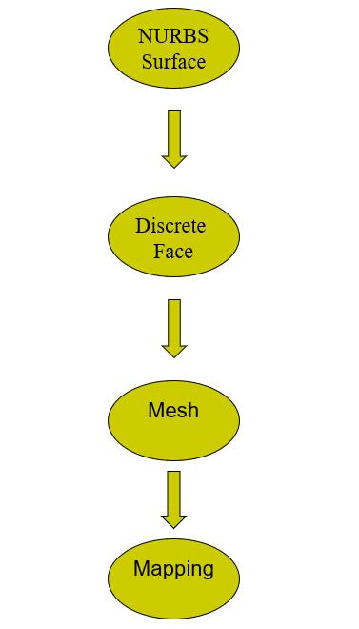

# 附 G-CODE

; external perimeters extrusion width = 0.40mm

; perimeters extrusion width = 0.67mm

; infill extrusion width = 0.67mm

; solid infill extrusion width = 0.67mm

; top infill extrusion width = 0.67mm

M107

M190 S70 ; set bed temperature

M104 S190 ; set temperature

G28 ; home all axes

G1 Z5 F5000 ; lift nozzle

M109 S190 ; wait for temperature to be reached

G21 ; set units to millimeters

G90 ; use absolute coordinates

M82 ; use absolute distances for extrusion

G92 E0

G1 E-3.00000 F1800.00000

G92 E0

G1 Z0.350 F4800.000

G1 X74.800 Y32.200 F4800.000

G1 E3.00000 F1800.00000

G1 X74.800 Y32.200 E3.00000 F600

G1 X76.900 Y32.700 E3.19623

G1 X79.000 Y33.200 E3.39245

G1 X80.800 Y33.800 E3.56492

G1 X82.800 Y34.200 E3.75032

G1 X84.200 Y34.800 E3.88878

G1 X85.600 Y35.200 E4.02113

G1 X86.800 Y35.800 E4.14309

G1 X88.000 Y36.200 E4.25807

G1 X89.200 Y37.000 E4.38916

G1 X90.400 Y37.600 E4.51112

G1 X92.000 Y38.800 E4.69292

G1 X93.600 Y39.800 E4.86443

G1 X95.800 Y41.600 E5.12282

G1 X97.600 Y43.200 E5.34173

G1 X99.800 Y45.400 E5.62455

G1 X101.400 Y47.200 E5.84346

G1 X103.000 Y49.200 E6.07628

G1 X103.800 Y50.600 E6.22285

G1 X104.800 Y52.000 E6.37924

G1 X105.200 Y53.000 E6.47714

G1 X105.800 Y54.000 E6.58315

G1 X106.200 Y55.000 E6.68105

G1 X106.800 Y56.000 E6.78706

G1 X107.200 Y57.000 E6.88496

G1 X107.800 Y58.000 E6.99097

G1 X108.200 Y59.400 E7.12332

G1 X108.800 Y60.800 E7.26178

G1 X109.200 Y62.800 E7.44718

G1 X109.800 Y64.800 E7.63698

G1 X110.200 Y68.800 E8.00239

G1 X110.400 Y72.400 E8.33014

G1 X110.400 Y76.600 E8.71192

G1 X110.200 Y80.200 E9.03966

G1 X109.800 Y84.200 E9.40508

G1 X109.200 Y86.200 E9.59488

G1 X108.800 Y88.200 E9.78028

G1 X108.200 Y89.600 E9.91874

G1 X107.800 Y91.000 E10.05109

G1 X107.200 Y92.000 E10.15710

G1 X106.800 Y93.000 E10.25500

G1 X106.200 Y94.000 E10.36101

G1 X105.800 Y95.000 E10.45891

G1 X105.200 Y96.000 E10.56491

G1 X104.800 Y97.000 E10.66282

G1 X103.800 Y98.400 E10.81921

G1 X103.000 Y99.800 E10.96578

G1 X101.400 Y101.800 E11.19860

G1 X99.800 Y103.600 E11.41751

G1 X97.600 Y105.800 E11.70033

G1 X95.800 Y107.400 E11.91924

G1 X93.600 Y109.200 E12.17763

G1 X92.000 Y110.200 E12.34914

G1 X90.400 Y111.400 E12.53094

G1 X89.200 Y112.000 E12.65289

G1 X88.000 Y112.800 E12.78399

G1 X86.800 Y113.200 E12.89897

G1 X85.600 Y113.800 E13.02093

G1 X84.200 Y114.200 E13.15328

G1 X82.800 Y114.800 E13.29173

G1 X80.800 Y115.200 E13.47714

G1 X79.000 Y115.800 E13.64961

G1 X75.400 Y116.200 E13.97886

G1 X72.000 Y116.400 E14.28845

G1 X68.000 Y116.400 E14.65205

G1 X64.600 Y116.200 E14.96165

G1 X61.000 Y115.800 E15.29090

G1 X59.200 Y115.200 E15.46337

G1 X57.200 Y114.800 E15.64877

G1 X55.800 Y114.200 E15.78723

G1 X54.400 Y113.800 E15.91958

G1 X53.200 Y113.200 E16.04154

G1 X52.000 Y112.800 E16.15652

G1 X50.800 Y112.000 E16.28761

G1 X49.600 Y111.400 E16.40957

G1 X48.000 Y110.200 E16.59137

G1 X46.400 Y109.200 E16.76288

G1 X44.200 Y107.400 E17.02126

G1 X42.400 Y105.800 E17.24018

G1 X40.200 Y103.600 E17.52300

G1 X38.600 Y101.800 E17.74191

G1 X37.000 Y99.800 E17.97473

G1 X36.200 Y98.400 E18.12130

G1 X35.200 Y97.000 E18.27769

G1 X34.800 Y96.000 E18.37559

G1 X34.200 Y95.000 E18.48160

G1 X33.800 Y94.000 E18.57950

G1 X33.200 Y93.000 E18.68551

G1 X32.800 Y92.000 E18.78341

G1 X32.200 Y91.000 E18.88942

G1 X31.800 Y89.600 E19.02177

G1 X31.200 Y88.200 E19.16023

G1 X30.800 Y86.200 E19.34563

G1 X30.200 Y84.200 E19.53543

G1 X29.800 Y80.200 E19.90084

G1 X29.600 Y76.600 E20.22859

G1 X29.600 Y72.400 E20.61037

G1 X29.800 Y68.800 E20.93811

G1 X30.200 Y64.800 E21.30353

G1 X30.800 Y62.800 E21.49333

G1 X31.200 Y60.800 E21.67873

G1 X31.800 Y59.400 E21.81719

G1 X32.200 Y58.000 E21.94954

G1 X32.800 Y57.000 E22.05555

G1 X33.200 Y56.000 E22.15345

G1 X33.800 Y55.000 E22.25945

G1 X34.200 Y54.000 E22.35736

G1 X34.800 Y53.000 E22.46336

G1 X35.200 Y52.000 E22.56127

G1 X36.200 Y50.600 E22.71766

G1 X37.000 Y49.200 E22.86423

G1 X38.600 Y47.200 E23.09705

G1 X40.200 Y45.400 E23.31596

G1 X42.400 Y43.200 E23.59878

G1 X44.200 Y41.600 E23.81769

G1 X46.400 Y39.800 E24.07608

G1 X48.000 Y38.800 E24.24759

G1 X49.600 Y37.600 E24.42939

G1 X50.800 Y37.000 E24.55134

G1 X52.000 Y36.200 E24.68244

G1 X53.200 Y35.800 E24.79742

G1 X54.400 Y35.200 E24.91938

G1 X57.000 Y37.800 E25.25361

G1 X59.600 Y40.400 E25.58785

G1 X62.800 Y43.000 E25.96264

G1 X66.400 Y45.800 E26.37721

G1 X70.000 Y48.800 E26.80318

G1 X72.400 Y49.000 E27.02209

G1 X75.000 Y49.200 E27.25913

G1 X77.000 Y49.800 E27.44894

G1 X78.600 Y50.400 E27.60427

G1 X80.400 Y51.400 E27.79144

G1 X82.200 Y52.400 E27.97861

G1 X84.000 Y53.800 E28.18590

G1 X85.800 Y55.400 E28.40481

G1 X87.600 Y57.200 E28.63621

G1 X89.400 Y59.600 E28.90891

G1 X91.000 Y62.400 E29.20205

G1 X92.200 Y65.000 E29.46235

G1 X93.400 Y68.000 E29.75606

G1 X94.200 Y70.800 E30.02076

G1 X94.400 Y73.400 E30.25780

G1 X94.400 Y75.600 E30.45778

G1 X94.200 Y78.400 E30.71295

G1 X93.800 Y80.600 E30.91621

G1 X93.200 Y82.800 E31.12349

G1 X92.800 Y84.400 E31.27341

G1 X91.800 Y86.400 E31.47667

G1 X91.000 Y87.800 E31.62324

G1 X89.600 Y89.600 E31.83052

G1 X88.000 Y91.400 E32.04944

G1 X86.000 Y93.400 E32.30654

G1 X84.200 Y95.000 E32.52546

G1 X82.000 Y96.800 E32.78384

G1 X79.600 Y98.000 E33.02775

G1 X76.800 Y99.200 E33.30466

G1 X73.600 Y99.800 E33.60061

G1 X70.200 Y100.200 E33.91180

G1 X67.000 Y100.000 E34.20325

G1 X64.400 Y99.800 E34.44029

G1 X62.400 Y99.200 E34.63010

G1 X60.800 Y98.600 E34.78543

G1 X59.400 Y97.600 E34.94182

G1 X57.800 Y96.600 E35.11333

G1 X55.800 Y95.000 E35.34614

G1 X54.000 Y93.400 E35.56506

G1 X52.000 Y91.400 E35.82216

G1 X50.400 Y89.600 E36.04108

G1 X49.000 Y87.800 E36.24836

G1 X48.200 Y86.400 E36.39493

G1 X47.200 Y84.800 E36.56644

G1 X46.800 Y83.200 E36.71636

G1 X46.200 Y81.400 E36.88883

G1 X45.800 Y79.000 E37.11000

G1 X45.600 Y76.200 E37.36517

G1 X45.600 Y73.600 E37.60151

G1 X45.800 Y70.800 E37.85668

G1 X46.600 Y67.600 E38.15651

G1 X50.400 Y66.800 E38.50950

G1 X54.400 Y66.200 E38.87717

G1 X59.000 Y65.600 E39.29885

G1 X63.800 Y65.600 E39.73517

G1 X68.400 Y66.600 E40.16308

G1 X70.400 Y66.200 E40.34848

G1 X72.400 Y66.600 E40.53388

G1 X74.000 Y67.600 E40.70539

G1 X75.400 Y69.000 E40.88536

G1 X76.600 Y71.200 E41.11316

G1 X77.200 Y73.400 E41.32044

G1 X77.400 Y75.400 E41.50315

G1 X76.800 Y77.600 E41.71043

G1 X75.600 Y79.800 E41.93822

G1 X70.600 Y79.600 E42.39309

G1 X65.800 Y79.400 E42.82979

G1 X61.200 Y79.400 E43.24793

G1 X57.200 Y79.200 E43.61198

G1 X54.200 Y79.400 E43.88529

G1 X55.000 Y81.200 E44.06434

G1 X56.400 Y83.400 E44.30138

G1 X58.000 Y85.400 E44.53419

G1 X60.000 Y87.400 E44.79130

G1 X61.800 Y89.000 E45.01021

G1 X64.000 Y90.400 E45.24725

G1 X66.000 Y91.400 E45.45051

G1 X68.000 Y92.000 E45.64032

G1 X70.000 Y92.200 E45.82302

G1 X72.000 Y92.000 E46.00573

G1 X74.000 Y91.400 E46.19553

G1 X76.000 Y90.400 E46.39879

G1 X78.200 Y89.000 E46.63583

G1 X80.000 Y87.400 E46.85475

G1 X81.800 Y85.600 E47.08614

G1 X83.400 Y83.400 E47.33342

G1 X84.600 Y81.200 E47.56121

G1 X85.400 Y79.200 E47.75702

G1 X86.000 Y76.800 E47.98189

G1 X86.200 Y74.200 E48.21893

G1 X86.000 Y72.000 E48.41973

G1 X85.400 Y69.600 E48.64461

G1 X84.400 Y67.200 E48.88095

G1 X83.200 Y65.000 E49.10874

G1 X81.600 Y63.200 E49.32766

G1 X79.800 Y61.400 E49.55905

G1 X78.200 Y60.000 E49.75231

G1 X76.400 Y58.800 E49.94895

G1 X73.800 Y58.000 E50.19623

G1 X71.400 Y57.600 E50.41740

G1 X68.800 Y57.800 E50.65444

G1 X64.600 Y55.200 E51.10345

G1 X60.400 Y53.000 E51.53443

G1 X57.000 Y51.200 E51.88413

G1 X53.400 Y49.400 E52.25000

G1 X50.200 Y47.600 E52.58374

G1 X48.400 Y49.200 E52.80266

G1 X46.600 Y51.000 E53.03405

G1 X44.400 Y54.000 E53.37222

G1 X42.600 Y57.200 E53.70596

G1 X40.800 Y60.600 E54.05566

G1 X39.400 Y64.000 E54.38989

G1 X38.200 Y67.400 E54.71764

G1 X37.800 Y70.200 E54.97474

G1 X37.600 Y73.400 E55.26619

G1 X37.600 Y76.400 E55.53889

G1 X37.800 Y79.600 E55.83033

G1 X38.200 Y82.600 E56.10545

G1 X38.800 Y84.800 E56.31273

G1 X39.200 Y86.400 E56.46265

G1 X39.800 Y88.000 E56.61798

G1 X40.200 Y89.000 E56.71588

G1 X40.800 Y90.000 E56.82189

G1 X41.200 Y91.000 E56.91979

G1 X42.200 Y92.400 E57.07618

G1 X43.000 Y93.800 E57.22275

G1 X44.400 Y95.600 E57.43004

G1 X46.000 Y97.400 E57.64895

G1 X48.000 Y99.400 E57.90606

G1 X49.800 Y101.000 E58.12497

G1 X51.800 Y102.600 E58.35779

G1 X53.600 Y103.800 E58.55444

G1 X55.200 Y104.800 E58.72595

G1 X56.800 Y105.600 E58.88855

G1 X58.200 Y106.200 E59.02701

G1 X59.800 Y106.800 E59.18234

G1 X61.600 Y107.200 E59.34995

G1 X63.600 Y107.800 E59.53975

G1 X66.000 Y108.200 E59.76092

G1 X69.000 Y108.400 E60.03423

G1 X72.200 Y108.400 E60.32511

G1 X75.000 Y108.200 E60.58028

G1 X77.800 Y107.800 E60.83738

G1 X80.000 Y107.200 E61.04466

G1 X81.800 Y106.600 E61.21714

G1 X83.200 Y105.800 E61.36371

G1 X84.800 Y105.000 E61.52631

G1 X86.400 Y103.800 E61.70811

G1 X88.200 Y102.600 E61.90476

G1 X90.200 Y101.000 E62.13758

G1 X92.000 Y99.400 E62.35649

G1 X94.000 Y97.400 E62.61360

G1 X95.600 Y95.600 E62.83251

G1 X97.000 Y93.800 E63.03980

G1 X97.800 Y92.400 E63.18637

G1 X98.800 Y91.000 E63.34276

G1 X99.200 Y90.000 E63.44066

G1 X99.800 Y89.000 E63.54667

G1 X100.200 Y87.600 E63.67902

G1 X100.800 Y86.000 E63.83435

G1 X101.200 Y84.000 E64.01975

G1 X101.800 Y81.800 E64.22704

G1 X102.200 Y78.800 E64.50215

G1 X102.400 Y75.600 E64.79360

G1 X102.400 Y72.400 E65.08448

G1 X102.200 Y69.200 E65.37592

G1 X101.000 Y64.800 E65.79049

G1 X99.400 Y61.000 E66.16528

G1 X97.800 Y57.600 E66.50685

G1 X95.800 Y54.200 E66.86542

G1 X93.600 Y51.200 E67.20359

G1 X91.800 Y49.400 E67.43498

G1 X90.000 Y47.800 E67.65390

G1 X88.200 Y46.400 E67.86118

G1 X86.400 Y45.200 E68.05783

G1 X84.800 Y44.200 E68.22934

G1 X83.200 Y43.400 E68.39194

G1 X81.800 Y42.800 E68.53040

G1 X80.200 Y42.200 E68.68573

G1 X78.400 Y41.800 E68.85334

G1 X76.400 Y41.200 E69.04315

G1 X73.400 Y39.200 E69.37089

G1 X70.100 Y37.100 E69.72645

G1 E6.95908 F1800.00000

G92 E0

M104 S0 ; turn off temperature

G28 X0 ; home X axis

M84 ; disable motors

; filament used = 148.9mm (0.4cm3)

; avoid_crossing_perimeters = 0

; bed_shape = -100x-100,100x-100,100x100,-100x100

; bed_temperature = 10

; before_layer_gcode =

; bridge_acceleration = 0

; bridge_fan_speed = 100

; brim_width = 0

; complete_objects = 0

; cooling = 1

; default_acceleration = 0

; disable_fan_first_layers = 1

; duplicate_distance = 6

; end_gcode = M104 S0 ; turn off temperature

G28 X0 ; home X axis

M84 ; disable motors

; extruder_clearance_height = 20

; extruder_clearance_radius = 20

; extruder_offset = 0x0

; extrusion_axis = E

; extrusion_multiplier = 1,1

; fan_always_on = 0

; fan_below_layer_time = 60

; filament_colour = #FFFFFF

; filament_diameter = 1.75,1.75

; first_layer_acceleration = 0

; first_layer_bed_temperature = 10

; first_layer_extrusion_width = 200%

; first_layer_speed = 30%

; first_layer_temperature = 190,190

; gcode_arcs = 0

; gcode_comments = 0

; gcode_flavor = reprap

; infill_acceleration = 0

; infill_first = 0

; layer_gcode =

; max_fan_speed = 0

; max_print_speed = 60

; max_volumetric_speed = 0

; min_fan_speed = 35

; min_print_speed = 10

; min_skirt_length = 0

; notes =

; nozzle_diameter = 0.4

; only_retract_when_crossing_perimeters = 1

; ooze_prevention = 0

; output_filename_format = [input_filename_base].gcode

; perimeter_acceleration = 0

; post_process =

; pressure_advance = 0

; resolution = 0

; retract_before_travel = 2

; retract_layer_change = 1

; retract_length = 3

; retract_length_toolchange = 10

; retract_lift = 0

; retract_restart_extra = 0

; retract_restart_extra_toolchange = 0

; retract_speed = 30

; skirt_distance = 6

; skirt_height = 1

; skirts = 1

; slowdown_below_layer_time = 30

; spiral_vase = 0

; standby_temperature_delta = -5

; start_gcode = G28 ; home all axes

G1 Z5 F5000 ; lift nozzle

; temperature = 190,190

; threads = 2

; toolchange_gcode =

; travel_speed = 80

; use_firmware_retraction = 0

; use_relative_e_distances = 0

; use_volumetric_e = 0

; vibration_limit = 0

; wipe = 0

; z_offset = 0

; dont_support_bridges = 1

; extrusion_width = 0

; first_layer_height = 0.35

; infill_only_where_needed = 0

; interface_shells = 0

; layer_height = 0.2

; raft_layers = 0

; seam_position = aligned

; support_material = 0

; support_material_angle = 0

; support_material_contact_distance = 0.2

; support_material_enforce_layers = 0

; support_material_extruder = 1

; support_material_extrusion_width = 0

; support_material_interface_extruder = 1

; support_material_interface_layers = 3

; support_material_interface_spacing = 0

; support_material_interface_speed = 100%

; support_material_pattern = pillars

; support_material_spacing = 2.5

; support_material_speed = 60

; support_material_threshold = 90

; xy_size_compensation = 0

; bottom_solid_layers = 3

; bridge_flow_ratio = 1

; bridge_speed = 60

; external_fill_pattern = rectilinear

; external_perimeter_extrusion_width = 0

; external_perimeter_speed = 70%

; external_perimeters_first = 0

; extra_perimeters = 1

; fill_angle = 45

; fill_density = 20%

; fill_pattern = honeycomb

; gap_fill_speed = 20

; infill_every_layers = 1

; infill_extruder = 1

; infill_extrusion_width = 0

; infill_overlap = 15%

; infill_speed = 60

; overhangs = 1

; perimeter_extruder = 1

; perimeter_extrusion_width = 0

; perimeter_speed = 30

; perimeters = 3

; small_perimeter_speed = 30

; solid_infill_below_area = 70

; solid_infill_every_layers = 0

; solid_infill_extruder = 1

; solid_infill_extrusion_width = 0

; solid_infill_speed = 60

; thin_walls = 1

; top_infill_extrusion_width = 0

; top_solid_infill_speed = 50

; top_solid_layers = 3